INTERNSHIP REPORT
by
STUDENT NAME

Submitted to: School of Computer Science and Engineering

International University, VNU-HCM

June 2024

Organization/Company: (name and address)

Duration of the Internship: 12 weeks (dd-mm-yy – dd-mm-yy)

Supervisor during the Internship: (name, title, address)

Supervisor’s signature: ___________________________________

IU’s Internship Coordinator: (name)

ACKNOWLEDGMENTS

Type your acknowledgments text here.

TABLE OF CONTENTS

List of Figures iv

List of Tables v

I. DESCRIPTION OF COMPANY/ORGANIZATION 1

II. SUMMARY OF THE INTERNSHIP 2

III. PLANNING 3

IV. INTERNSHIP ACTIVITIES & ACHIEVEMENTS 5

V. INTERNSHIP ASSESSMENT 10

APPENDIX….. 12

REFERENCES 14

This page was produced with tab settings as shown:
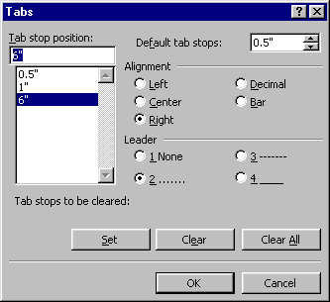

Outline for Internship Report

The 1st page: should display the student's name and information related to the student’s internship as shown above
Acknowledgments
Table of content
List of figures
List of tables
Description of the company/organization: this section has an introduction to the company that the intern has attended during the internship period. The section should contain: the full title of the company/organization, mailing address, web links, type of the ownership of the company, specify product and services offered to customers, provide an organization chart of the company, and specify the functions of your internship department
Summary of the internship (or statement of purpose): one or two pages summary of the intern’s major activities during the internship period
Planning: a weekly timetable showing activities that have been accomplished during the internship period
Internship activities & achievements: this is the main body of your report, you should present the activities performed during the internship period in detail.
Internship assessment: in this section, you should answer the following questions: what kind of skills/qualifications you have gained during the internship period? what kind of responsibilities you have undertaken during the internship? how do you think the internship will influence your future career plans? how do you think the internship activities you carried out correlate with your coursework at school?
Appendix and supplemental materials
Reference

Format of your document:

Your document should be written using Times New Roman 12-point, double spacing. Margins for the document are shown below:

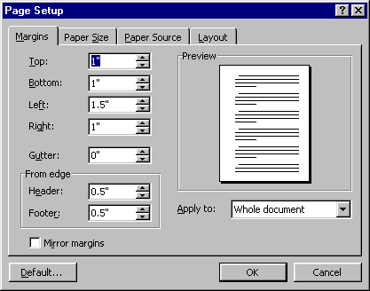
Layout:
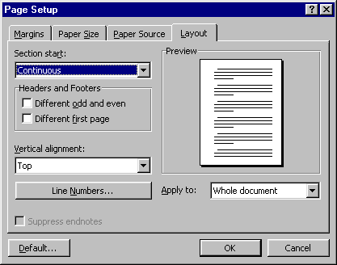

The “paper size” should be “letter” and oriented in “portrait mode”:

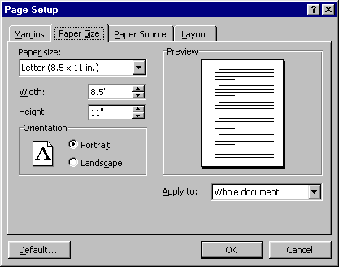

Now move to the “Format” menu and select “Paragraph”. The following screen shows a paragraph with double spacing, no indentation of the first line, fully justified on both left and right sides of the page, but with a “hanging” indent of half an inch on each subsequent line of the paragraph. This produced the results shown in this paragraph.

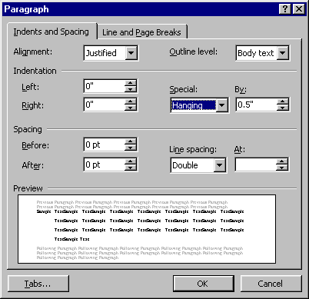
The next screen shows how to select a paragraph with double spacing, ragged right margins, and no hanging indentation, but with the first line of the paragraph indented by half an inch. This format was used for the present paragraph (and most of the paragraphs in this template). For other formats, adjust accordingly.
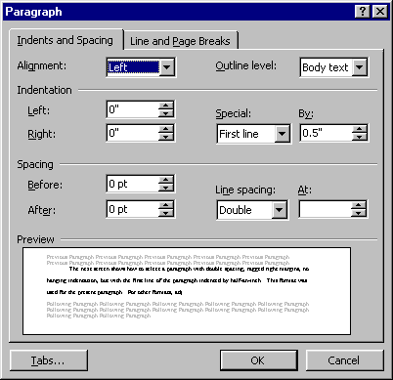

Now let’s see how to produce page numbering in the right places. After the first page of each chapter, and at the end of each chapter, place a “Section Break” (under the “Insert” Menu, under “Break”). Set it up as shown:

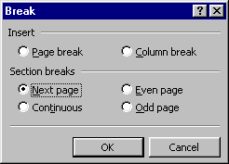

(You can see the section breaks in this template by going to the “View” menu and selecting “Page Layout.”) Then go to the “View” Menu and go to “Headers and Footers.” For each section, set up the header and footer by inserting page numbers in the appropriate place, or leaving them blank, as appropriate. Make sure to switch off the “Same as Previous” block at the top right corner of the header/footer block. To see examples, check out the headers and footers of this template. The idea here is that by treating the first page of each chapter as a separate “section,” you can paginate it differently than the bulk of the chapter, which constitutes a separate “section.” Set up all the “front matter” as a separate section and use the “Bottom Center” pagination format.

Figures, Tables and Link to Them in Content

Figures are used to display pictures, diagrams, charts… Generally, each figure is a stand-alone piece of information. The figure’s title is center alignment, separately numbered in each chapter and placed after the figure. The list of abbreviations and essential explanations or notes about the figure can place after the figure’s title and formatted differently from normal text. Figures can have borders to separate text. A sample of figure representation can be seen in Figure 2.1.

Stage 1
Pre-processing

Data

Stage 2
Model Learning

Stage 3
RE&V

Consulting Advices

Figure 2.1 – A sample of figure representation
Notes:
RE&V: Rules Extraction and Validation.

Whenever a figure is placed in the document, links to this figure have to be made in the content. Common mistakes are placing a figure without any link or wrongly linking as “the diagram is displayed in the following figure:” or “the above/following figure displays…”. The correct way to link to figure in content can be one of the following cases:
- Figure 2.1 displays the model of processing data.
- Data is processed in several consequent stages as in Figure 2.1.
- Data is processed in several consequent stages (see Figure 2.1).

Tables are used to represent data required to be displayed in columns and rows. The format and link of the tables are similar to the figures. The only different point is the table’s title is placed in front of the table.

References
Number citations consecutively in square brackets [1]. The sentence punctuation follows the brackets [2]. Multiple references [2], [3] are each numbered with separate brackets [1]–[3]. When citing a section in a book, please give the relevant page numbers [2]. In sentences, refer simply to the reference number, as in [3]. Do not use “Ref. [3]” or “reference [3]” except at the beginning of a sentence: “Reference [3] shows ... .” Unfortunately the IEEE document translator cannot handle automatic endnotes in Word; therefore, type the reference list at the end of the paper using the “References” style. Remember that only cited references are added to the reference list.
Please note that the references at the end of this document are in the preferred referencing style. Give all authors’ names; do not use “et al.” unless there are three authors or more. Use a space after the authors' initials. Papers that have not been published should be cited as “unpublished” [4]. Papers that have been submitted for publication should be cited as “submitted for publication” [5]. Papers that have been accepted for publication, but not yet specified for an issue should be cited as “to be published” [6]. Please give affiliations and addresses for private communications [7].
Capitalize only the first word in a paper title, except for proper nouns and element symbols. For papers published in translation journals, please give the English citation first, followed by the original foreign-language citation [8].
References
- G. O. Young, “Synthetic structure of industrial plastics (Book style with paper title and editor),” in Plastics, 2nd ed. vol. 3, J. Peters, Ed. New York: McGraw-Hill, 1964, pp. 15–64.
- W.-K. Chen, Linear Networks and Systems (Book style). Belmont, CA: Wadsworth, 1993, pp. 123–135.
- H. Poor, An Introduction to Signal Detection and Estimation. New York: Springer-Verlag, 1985, ch. 4.
- B. Smith, “An approach to graphs of linear forms (Unpublished work style),” unpublished.
- E. H. Miller, “A note on reflector arrays (Periodical style—Accepted for publication),” IEEE Trans. Antennas Propagat., to be published.
- J. Wang, “Fundamentals of erbium-doped fiber amplifiers arrays (Periodical style—Submitted for publication),” IEEE J. Quantum Electron., submitted for publication.
- C. J. Kaufman, Rocky Mountain Research Lab., Boulder, CO, private communication, May 1995.
- Y. Yorozu, M. Hirano, K. Oka, and Y. Tagawa, “Electron spectroscopy studies on magneto-optical media and plastic substrate interfaces(Translation Journals style),” IEEE Transl. J. Magn.Jpn., vol. 2, Aug. 1987, pp. 740–741 [Dig. 9th Annu. Conf. Magnetics Japan, 1982, p. 301].

